ABSTRACT

LIPOSUCTION NORMALIZES LYMPHEDEMA INDUCED ADIPOSE TISSUE HYPERTROPHY IN ELEPHANTIASIS OF THE LEG – A PROSPECTIVE STUDY WITH A 15 YEARS’ FOLLOW-UP

Håkan Brorson MD PhD^{1,2}, Karin Ohlin ROT², Barbro Svensson RPT LT², Mattias Hoffner MD PhD^{1,3}, Tobias Karlsson MD^{1, 2}

¹Department of Clinical Sciences, Lund University, Sweden
²Department, Plastic and Reconstructive Surgery, Skåne University Hospital, Malmö, Sweden
³Department of Surgery, Blekinge Hospital, Karlskrona, Sweden

Background
Patients with long-standing pronounced non-pitting lymphedema do not respond to conservative treatment or microsurgical procedures because slow or absent lymph flow, as well as chronic inflammation, cause the formation of excess subcutaneous adipose tissue, which cannot be removed by these methods.

Aim
The swelling of chronic non-pitting arm lymphedema following breast cancer can be completely reduced by liposuction and has not recurred during 24 years' follow-up. Encouraged by this experience, we decided to evaluate the effectiveness of liposuction on leg lymphedema.

Material and Method
111 patients with a mean±SEM age of 49±1.5 years, and with a duration of leg swelling of 14±1.1 years underwent liposuction due to non-pitting, chronic lymphedema. There were 50 primary (PL), and 46 secondary lymphedemas (SL) following cancer therapy. Age at cancer treatment, and interval between cancer treatment and lymphedema start were 41±2.0 years and 2.5±0.7 years respectively. Age at onset of PL was 28±2.1 years (Figure 1, 2)

Results
Aspirate volume was 3642±167 ml with an adipose tissue concentration of 93±1.1% in the tourniquet fraction. Preoperative excess volume was 3733±188 ml. Postoperative mean reduction was 79±2.5% at 3 months and 100±2.3% at 1 year, and more than 100% during 15 years’ follow-up, i.e. the lymphedematous leg was somewhat smaller than the healthy one. The preoperative mean ratio between the volumes of the edematous and healthy legs was 1.4±0.02, rapidly declining to 1.0±0.01 at 1 year and less than 1 after one year.

Conclusion
Liposuction is an effective method for treatment of chronic, non-pitting leg lymphedema in patients who have failed conservative treatment. It is the only known method that completely reduces excess volume at all stages of lymphedema. The removal of hypertrophied adipose tissue is a prerequisite to complete reduction. The reduced volume is maintained through constant use of compression garments.

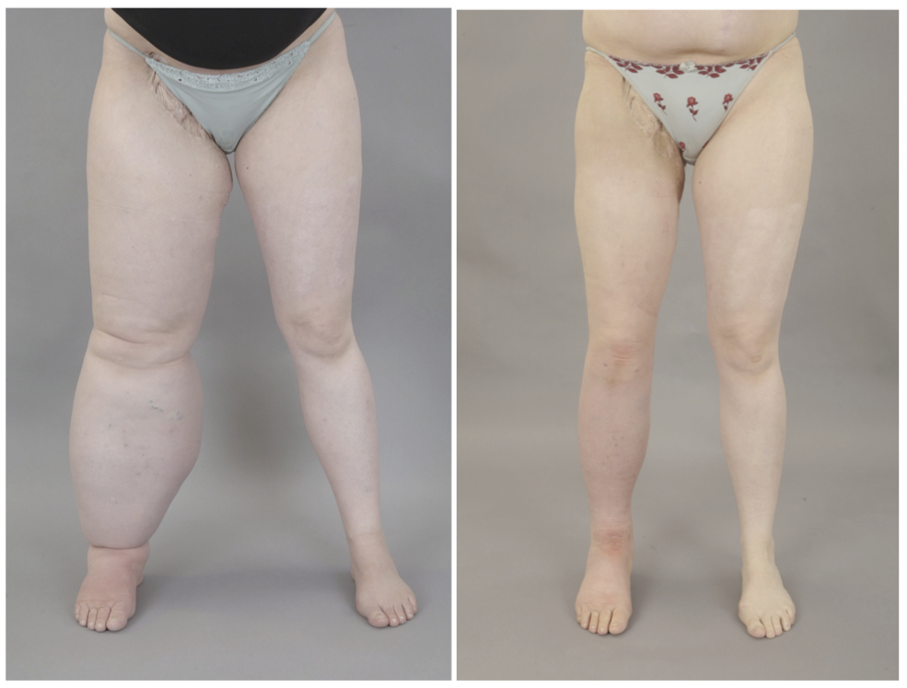
Fig. 1. A 32-years-old woman with a non-pitting secondary leg lymphedema of 7 070 ml since 12 years following treatment of a synovial sarcoma in the right groin (left). Postoperative result 6 months after liposuction (right).

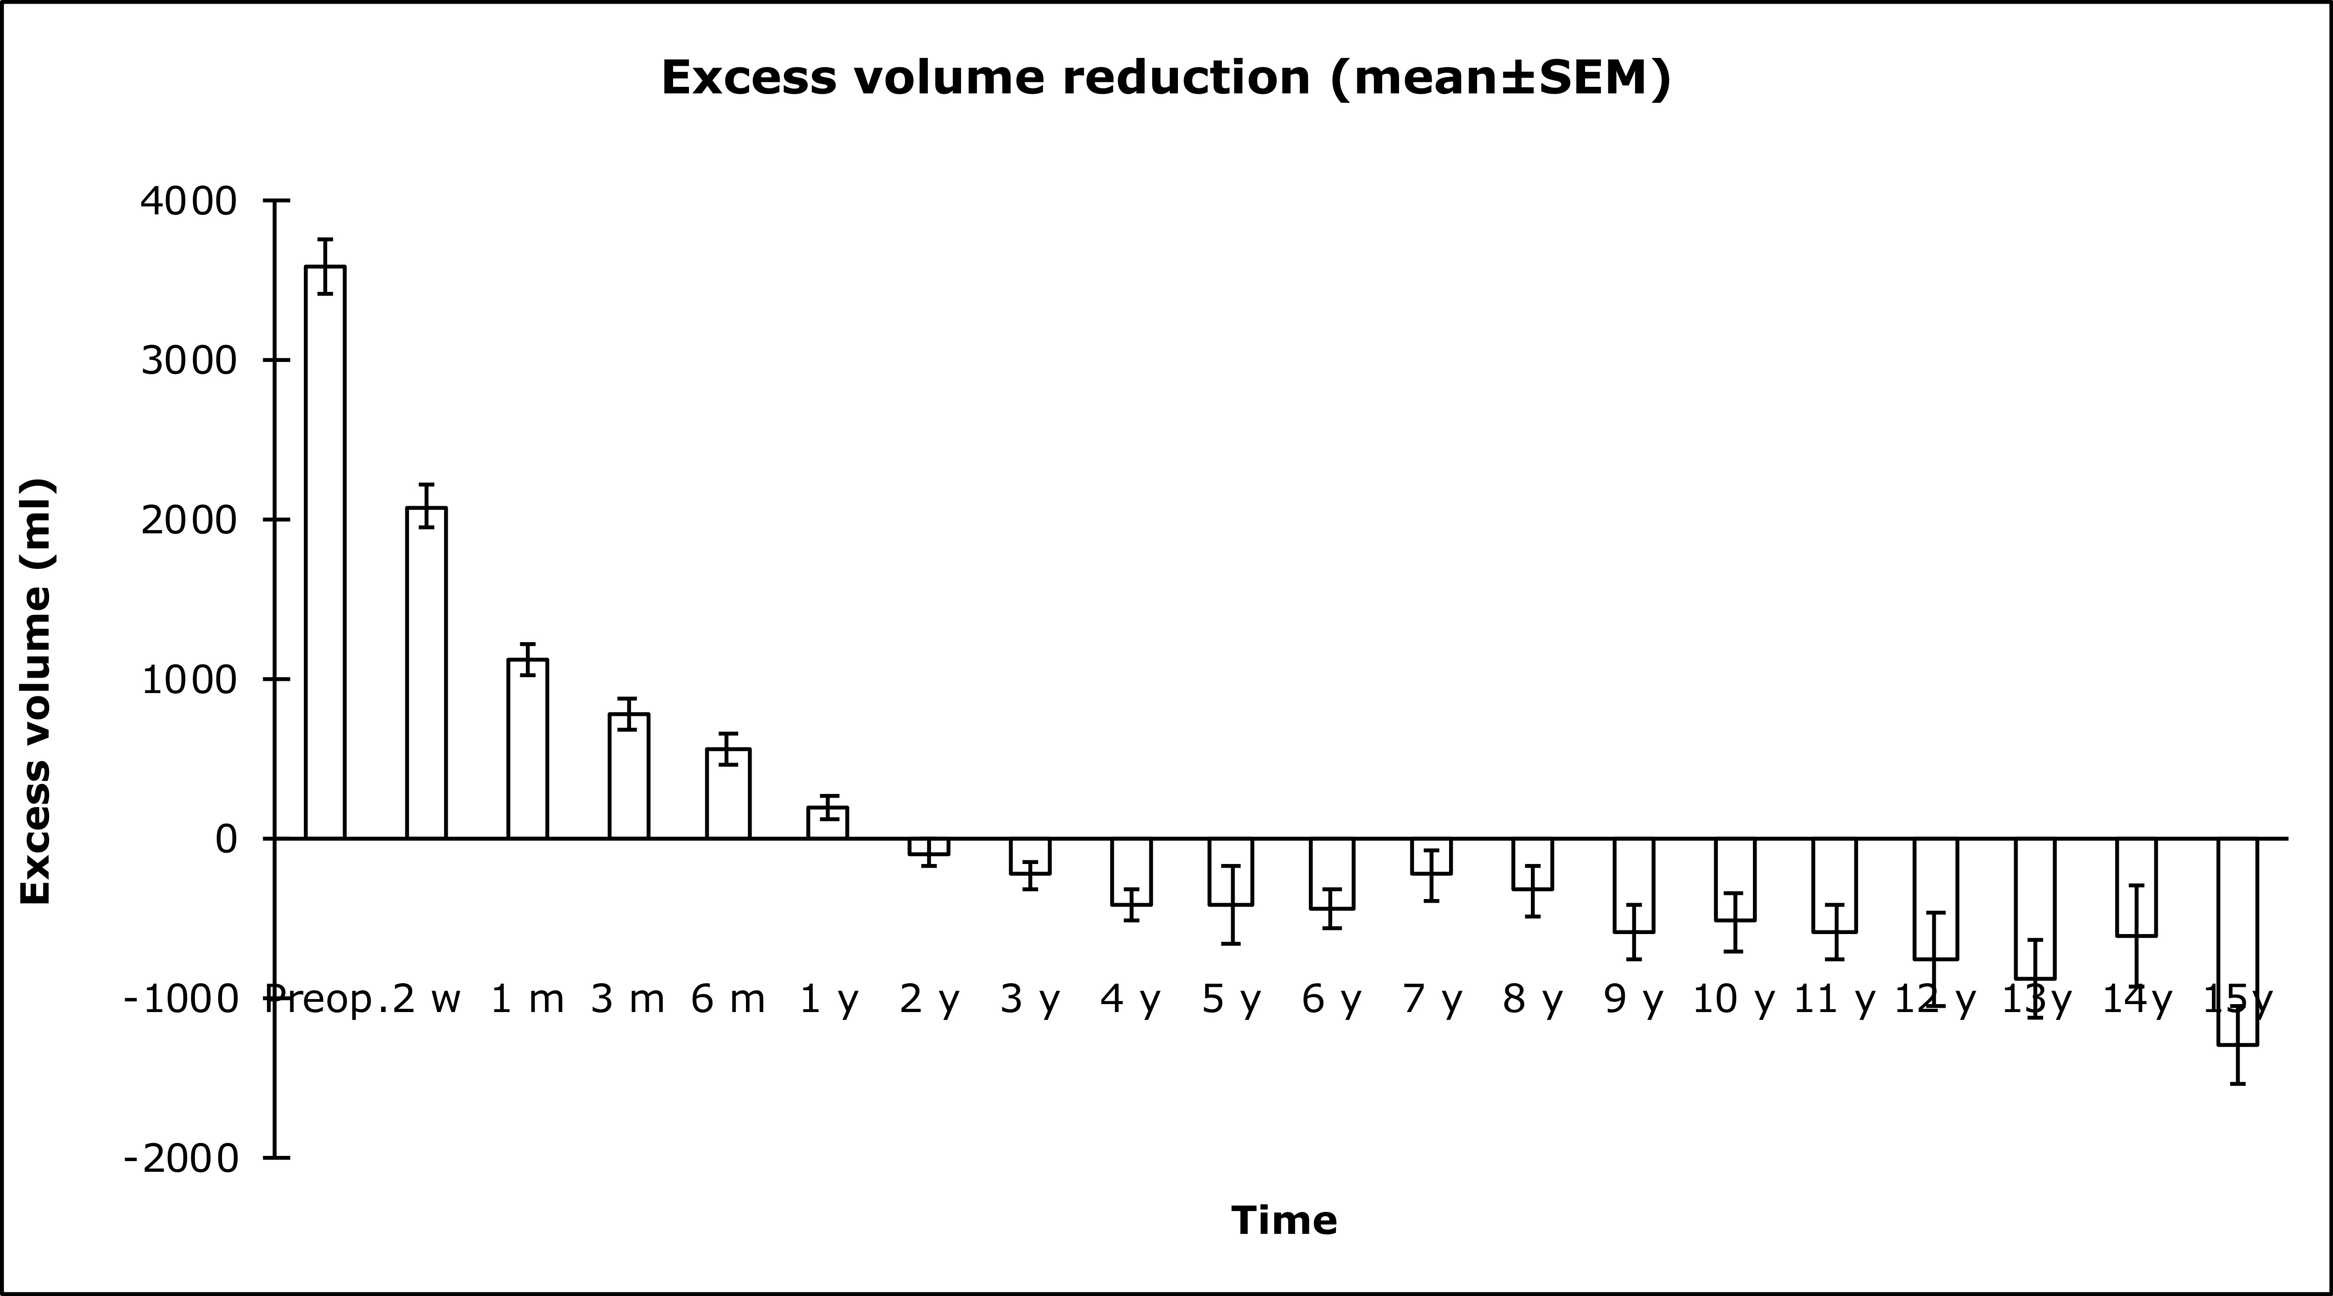
Fig. 2. Mean pre- and postoperative excess volume reduction following liposuction of leg lymphedema.

